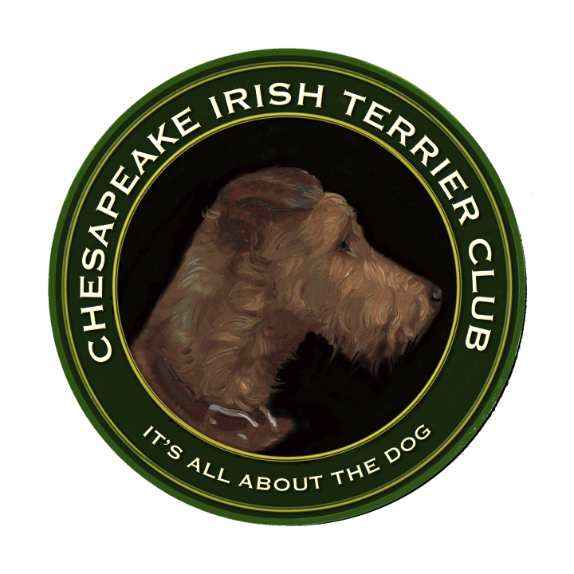CHESAPEAK IRISH TERRIER CLUB ANNOUNCES
2012 GROOMING WORKSHOP
MEETING & LUNCHON

DATE: Sunday, June 10, 2012

TIME: 12-1PM CITC Meeting and Luncheon
1- 4PM Grooming Workshop

LOCATION: Mr. and Mrs. Rick LePere’s Home&Garden
4020 Fordham Road, NW
Washington, DC 20016

LUNCHEON COORDINATOR: Julia Overton

VOLUNTEER INSTRUCTORS: CITC club members, Doug Rapport, Eleanor Hillegeist and Dana LePere. Volunteer groomers from the Irish Terrier Club of America (ITCA). The instructors will focus on pet grooming and will try to answer your grooming questions and help you learn more about grooming your Irish Terrier. We hope to have one grooming instructor available to work with two club members and their Irish during to provide as much individual attention as possible. This year’s workshop follows last year’s CITC Grooming Seminar conducted by AKC Judge Mr. Todd Clyde. This year will be a hands-on grooming workshop with no seminar.

WHAT YOU NEED TO BRING:
Your grooming questions & skills and your Irish Terrier. Bring a leash, crate, water bowl and whatever grooming tools you own. At this workshop our Irish Terriers are required to be on their leads, on the grooming table or in their crates for safety reasons. The lovely garden contains plenty of space for us to exercise our dogs on their leashes, visit and enjoy our terriers.

MORE INFORMATION AND REMINDER TO FOLLOW

